**How to apply k-means clustering into the code :**

**(1) Read and plot our dataset :**

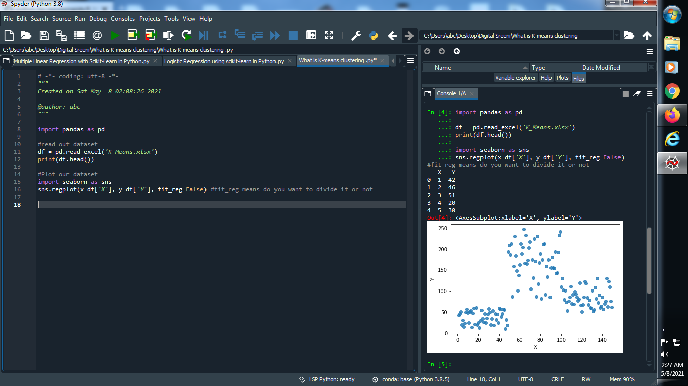

**Output :**



**(2) Apply K-means clustering :**

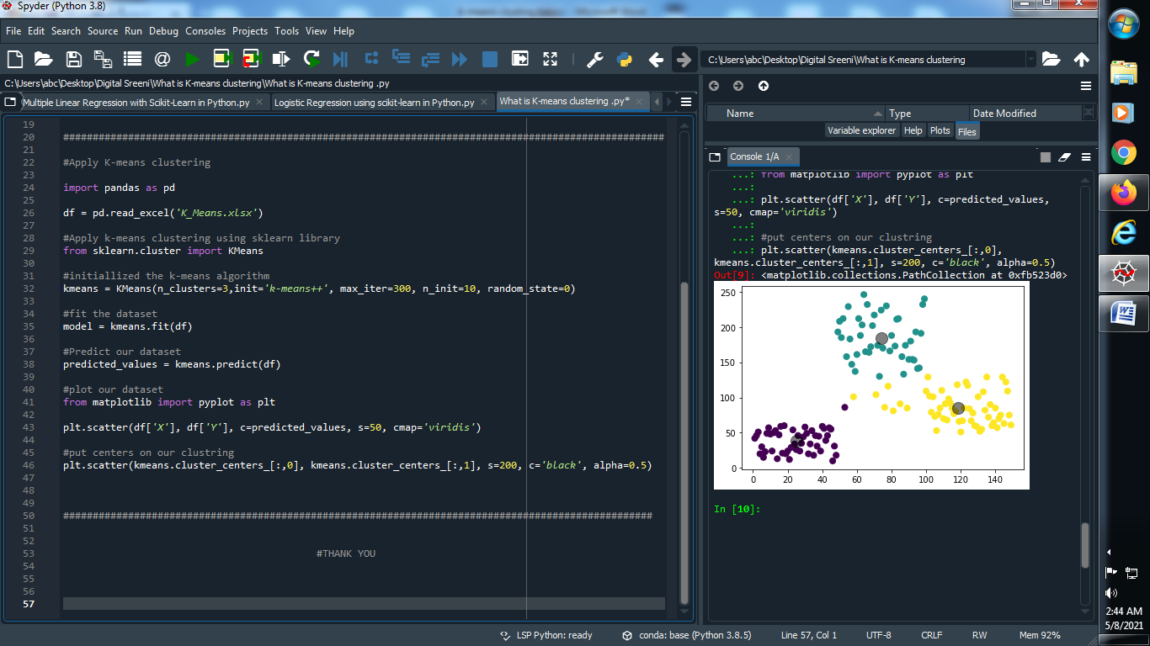

**Output :**

